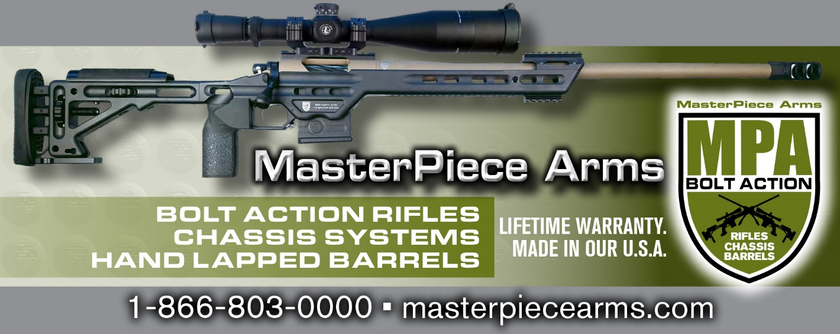

Masterpiece Arms BA Chassis System Installation, Setup and Usage
Thank you for purchasing the finest rifle chassis system on the market today. Your system has been developed from input from the nation’s top shooters, along with design enhancements using state of the art solid modeling software systems. Please review the installation, setup and usage information below. If you have any questions at anytime during the ownership of this Masterpiece, please contact us.
Installation:
To install your barreled action into your MPA BA Chassis system, follow these steps:
- Remove the (2) included and labeled Action Screws from the plastic bag.
- Remove the Night Vision Bridge.
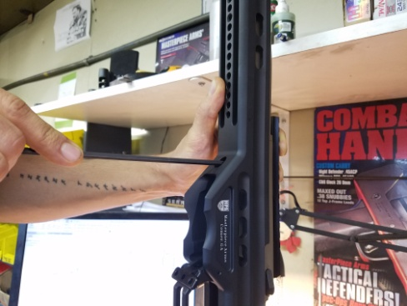
- Place your barreled action into the chassis with the recoil lug inserted into the slot in the chassis and the trigger into the trigger pocket in the chassis.
- Make sure the recoil lug clears the round cylinder that is part of the lug lock system. Check out this video to better understand the lug lock. https://youtu.be/oSm8BCAn4FM
- MPA Chassis now use a Wedge Lock Action screw system. This system utilizes 2 washers with each action screw. The washers should be installed with the small serrations facing away from each other (towards the fastener head and chassis).
- Using a 3/16 hex wrench, place the short action screw and washers onto the hex wrench and prepare to insert into the front action screw hole in the chassis.
- Place your hand over the top of the barreled action and chassis to hold secure while you insert the shortfront action screw into the chassis, allowing the screwto engage the threads in the action. Just get the screw started, but do not tighten.
- Using the same 3/16 hex wrench, install the long action screw into the rear action screw hole in the chassis and get the threads started, but do not tighten.
- While still holding the chassis and barreled action, turn the assembly up so the rifle is sitting on the buttstock. This puts all the weight of the barreled action on to the recoil lug in the slot in the chassis.
- Using the same 3/16 hex wrench, snug up the front action screw, then the rear one. Do not over tighten these action screws.
- Using an inch lb torque wrench, torque the front action screw to 25 inch lbs or just past hand tight. Then do the same for the rear screw.
- Then go back to the front action screw and torque to the final spec of 65 inch lbs. Then return to the rear and do the same.
- Its very important that you always start with the front action screw, then the rear, in that order.
- Once both front and rear screw are tightened to 65 inch lbs check wedge lock impression by listening for the audible pop and feeling the fastener break free. See full video for details.
https://youtu.be/fKSoa2TXlc0. If more torque is required, reapply action crews as prescribed above using slightly more torque and recheck for wedge lock engagement.
- After completion of the action screw installation, tighten the flat head cap screw that is part of the lug lock system down the 25-30 inch lbs.
- Replace the Night Vision Bridge.
- Congratulations, your barreled action is installed.

Items to check after installation:
- Make sure there is no contact with the barrel and the chassis at the front of the chassis.
- Make sure there is no contact with the night vision bridge and your barrel at the front of the chassis.
If either of these conditions exists, contact MPA.
Savage Short Action Chassis
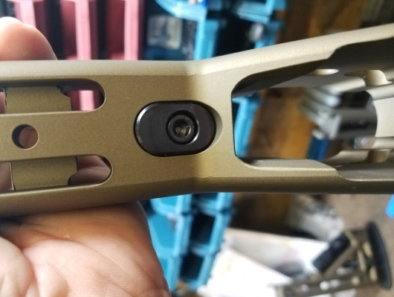
For Savage Short Action Chassis, there are two inserts that are included with the chassis. These are to accommodate all three of the action screw spacings on the three generations of Savage Short Actions. To determine which insert and orientation is needed to match up with your action screw spacing, place your barreled action into the chassis as described in step 5 above – without the insert in place in the chassis. Take a look at the location of the threaded hole in the action through the slot in the chassis. You should easily be able to determine which insert is needed. Then place the appropriate insert in the chassis, the front action screw goes through this insert into the action’s threaded hole.
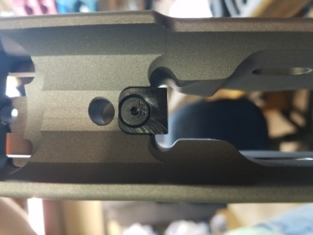
Remington Long Action Chassis
For Remington Long Action Chassis, there is an insert that is located at the front of mag well that provides the proper amount of clearance for the three potential magazine lengths that can be used with this long action chassis. The three potential magazine lengths are 3.715 and 3.850. These are the overall length of the magazines (not internal capacity). There is an insert for each of these mag lengths and the proper one should have been sent with the chassis. If you have the wrong insert or start using a different length magazine, please contact Customer Service at MPA for a replacement.

Setup
After installing your barreled action into the chassis, its time to setup the chassis to fit your body size and type.
- Length of Pull – On Standard BA, ESR and Competition BA Chassis, there is a thumb wheel to adjust the length of pull to your desired location so that the rifle is comfortable while in a prone position and you are able to work the bolt in the action easily and efficiently. Once you have the length of pull adjusted to your location, you have the options (not required) to use the 2 installed set screws to tighten down on the recoil plate rods that will lock in the LOP.
  - For BA Lite and Hybrid Chassis, follow the same method, but the LOP will be adjusted manually – not with thumb wheels. You must use the set screws to secure the LOP.
- Mount Your Optic – The use of the inclinometer (bubble level) in the MPA Chassis gives you the absolute best method of setting up your optic so that you do not have axis errors in the perpendicularity and parallelism of the reticle in your scope. To setup your optic properly, follow these instructions:
  - Place your rifle in a location that will allow you to see a true vertical alignment component through your optic. This would be a surface that is perfectly vertical. The easiest method of doing this is with a heavy piece of string tied to a weight – forming a “plumb bob” hanging 50-100 yards from your optic.
  - Get your optic mounted on the action with the top cap of the mount or rings installed but not tight. (you should be able to rotate and move the optic in the rings).
  - Ensure your chassis is level by verifying the bubble in the level is centered.
  - Look through your optic while behind the rifle to set the proper amount of eye relief.
  - Then rotate the optic until the vertical line on your reticle is perfectly aligned with your true vertical surface (plumb bob).
  - Verify your rifle/chassis is still level by using the bubble level in the chassis.
  - Then tighten down on the ring caps to manufacturer’s torque spec to secure your optic.
  - Then verify that your rifle is level and the vertical line in the reticle is still flush with your plumb bob line. If not, loosen the ring caps and adjust as needed.
  - When using this method, DO NOT USE A SECONDARY LEVELING SYSTEM WHILE ATTEMPTING TO SETUP YOUR OPTIC.
- Cheek Riser Position – Adjust your cheek riser position so that your eye position is perfectly aligned with the center of the reticle in your optic. Once you have it in a position that you feel is appropriate, break your position, then re-engage your rifle with your cheek in position – WITH YOUR EYES CLOSED. Then open your eyes while still engaged with your rifle. If your sight picture through the optic is perfect, no further adjustments are needed. If your eye is not aligned with the center of the reticle, you will know it. Further adjustment is needed. Once the proper height if the cheek riser is set, you have the option (not required) to tighten the 2 installed set screws to lock the position in height.
  - For BA Light and Hybrid Chassis, follow the same setup method, but the positioning of the cheek riser will be manual, not with the thumb wheels. Use the set screws to secure the position.
- Night Vision Bridge – if your objective housing or sun shade interferes with the Night Vision Bridge, contact MPA for your options or simply do not use the supplied Night Vision Bridge.
- Pistol Grip – We include a specifically designed EVG (Enhanced Vertical Grip). In some cases the user may wish to swap out this grip for another. There are many different varieties of pistol grips available on the market. Any A2 Type Pistol Grip can be attached to the MPA Chassis. Use a 3/16 T-Handle or Allen Wrench to remove the Socket Head Cap Screw and Star Washer that holds the grip in place. Replace the grip with the version of your choice and re-install the fastener with Washer.
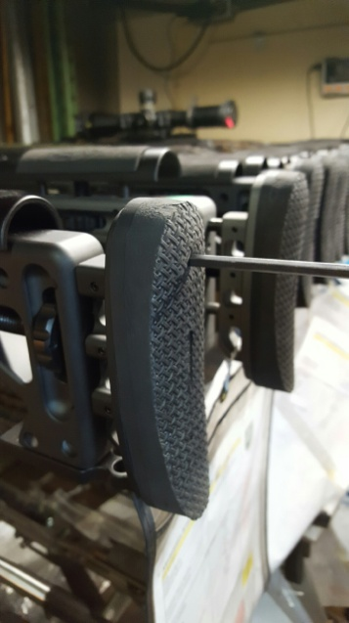
- Recoil Pad Adjustment – If you notice on the back of the recoil plate (that secures the Recoil Pad), there are a series of drilled and tapped holes. These are used to adjust the Recoil Pad if needed. To adjust, the height and or cant of the pad, use a 5/32 Allen Wrench to remove the 2 Socket Head Cap Screws that hold the pad in place. Adjust the pad location as needed and re-install the screws. Please note, this is an advanced setup technique and the adjustment should enhance your natural point of aim and overall consistency when engaging the rifle.
- Spigot Bipod Mount- If your chassis is equipped with a spigot then you have 2 options for mounting a bipod. The spigot mount is double sided and includes the standard pic rail on one side and the RAT Rail (1.5” ARCA Rail) on the other. To switch between mounting options simply looses the two fasteners on the underside of the front fore-end, pull out spigot and flip, then reinsert into spigot hole and retighten fasteners.
- Bag Rider- The bag rider on you chassis is designed to be adjustable so the user can achieve maximum comfort and function. The position can quickly be adjusted by loosening the 3 fasteners and sliding the bad rider forward and back. Please not that the position of the butt plate will limit how much the bad rider can move. If a larger bag rider or one with a butt hook is desired the user can upgrade to the MPA Ultra Bag rider.

Usage
The general usage of the MPA Chassis is like any other bolt action stock or chassis – after the setup is properly completed.
The chassis and rifle should be extremely comfortable and easy to shoot. If not, ensure you have the adjustments on the chassis properly set for your comfort. This may take a few tries but once properly setup it will allow the shooter to have the best accuracy results possible. If you are having issues getting comfortable with the MPA Chassis, please contact our Customer Service department or MPA Academy and we will provide the assistance needed to get the setup fine tuned.
After 100-125 rounds through the rifle after the chassis is installed, verify the torque on the action screws is still at 65 inch lbs. There can be an initial settling of the barreled action, action screws and overall setup in the chassis that can allow the screws to slightly loosen. Repeat this verification again after 500 rounds and periodically throughout the life of your chassis. This is considered standard maintenance on any rifle chassis system.
There are many application oriented uses of the MPA chassis depending on the usage of the rifle. Please visit our website and check out the video page for tutorials on many of these specialized techniques of the MPA Chassis system.
Masterpiece Arms
4904 Hwy 98
Comer, GA. 30629
www.masterpiecearms.com
866-803-0000
Bolt Action Customer Service – X8.

